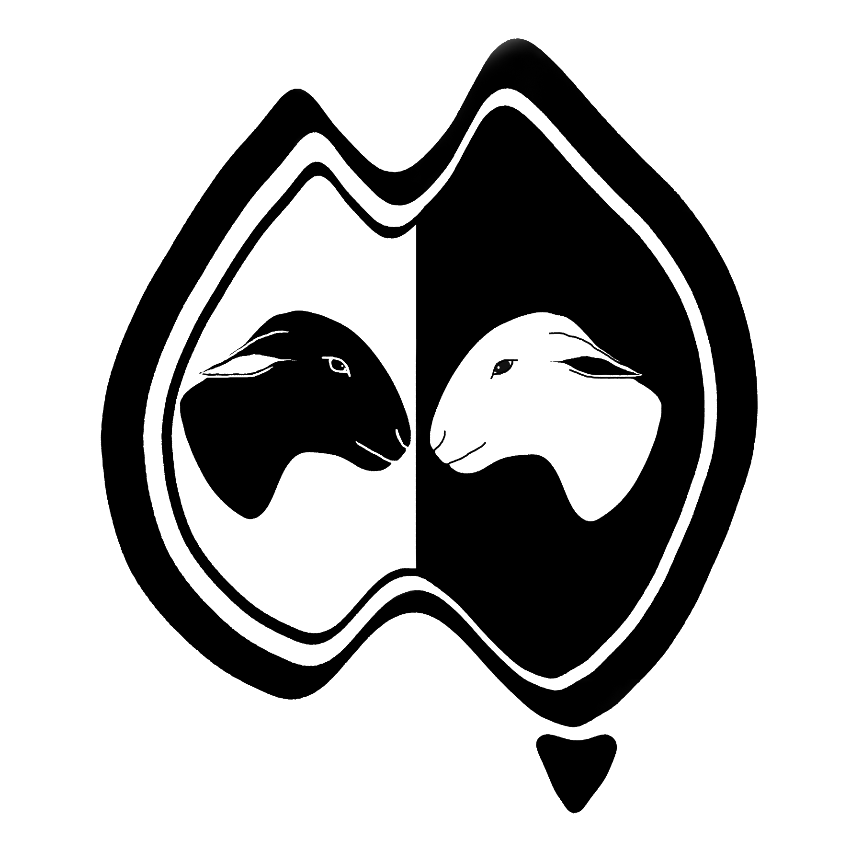
AUSTRALIAN DORPER & WHITE DORPER ASSOCIATION
BULK EWE / RAM FORM
Registration & Transfer
PO Box 108, Goodwood SA 5034
Secretary: Ms Kira Bains
Phone: (08) 8210 5215 l Email: kbains@adelaideshowground.com.au

Please indicate: I submit the following animals for REGISTRATION and/or TRANSFER
MEMBERSHIP NAME:
STUD PREFIX: |  | ADWDA FLOCK NUMBER:

NEW REGISTRATION ANIMAL INFORMATION |  |  |  |  |  |  | SIRE INFORMATION |  |  |  |  | DAM INFORMATION
BREED  (D or WD) | SEX  (M or F) | DOB  (DD/MM/YY) | EARTAG  (6-DIGIT) |  | NATURAL  or EMBRYO |  | SIRE PREFIX | EARTAG |  | REG NO.  (if known) |  | DAM PREFIX | EARTAG |  | REG NO.  (if known) |  | Certificate
 |  |  |  |  |  |  |  |  |  |  |  |  |  |  |  |  | YES
 |  |  |  |  |  |  |  |  |  |  |  |  |  |  |  |  | YES
 |  |  |  |  |  |  |  |  |  |  |  |  |  |  |  |  | YES
 |  |  |  |  |  |  |  |  |  |  |  |  |  |  |  |  | YES
 |  |  |  |  |  |  |  |  |  |  |  |  |  |  |  |  | YES
 |  |  |  |  |  |  |  |  |  |  |  |  |  |  |  |  | YES
 |  |  |  |  |  |  |  |  |  |  |  |  |  |  |  |  | YES
 |  |  |  |  |  |  |  |  |  |  |  |  |  |  |  |  | YES
 |  |  |  |  |  |  |  |  |  |  |  |  |  |  |  |  | YES
IF THE ABOVE EWES ARE MATED, please indicate : |  |  |  | SIRE PREFIX |  |  |  |  | SIRE EARTAG |  |  |  |  | SIRE REG NO.

TRANSFER OF OWNERSHIP: Please complete if ALL animals listed above are to be transferred to one owner
New Owner: |  |  |  | Date of Transfer
Address: |  |  |  | Existing Member? | Yes No
 | If existing member, please advise stud details for transfer: | Stud Prefix: |  | Flock Number:

